

VISVESVARAYA TECHNOLOGICAL UNIVERSITY

BELAGAVI – 590018

PROJECT SYNOPSIS
on

“FRAUDIFY-FIGHTING FINANCIAL CRIME DETECTION USING MACHINE LEARNING”
Submitted in partial fulfillment of the requirement of the Seventh Semester

Bachelor of Engineering In
COMPUTER SCIENCE AND ENGINEERING
Submitted By

THEJASHREE C G 1BO21CS064
VAISHALI G V 1BO21CS065
VIBHA S GOWDA 1BO21CS066
CHARANA R 1BO22CS405

Under the Guidance of
Prof. SMITHA B M
Asst. Prof., Dept. of CSE



DEPARTMENT OF COMPUTER SCIENCE AND ENGINEERING
DWARAKANAGAR, BAGALUR MAIN ROAD, YELAHANKA, BENGALURU-63, 2024 – 2025

AIM & OBJECTIVE

AIM:

The primary aim of this project is to detect and prevent fraudulent UPI transactions by utilizing advanced Machine Learning algorithms, including Hidden Markov Models (HMM). The goal is to develop a robust and efficient system capable of identifying potentially fraudulent transactions in real-time, reducing financial losses for users and financial institutions. It aims to analyze users' transaction patterns and identify anomalies indicative of fraud. By training models on historical data and testing multiple algorithms, the project ensures that the system can handle challenges such as imbalanced data and evolving fraud techniques. The ultimate goal is to create a reliable, real-time fraud detection system to safeguard users and financial institutions, promoting secure UPI usage.

OBJECTIVE:

- To Analyze UPI Transaction Data which is to study the transaction patterns of UPI users to understand legitimate behavior.
- To Develop and Test Machine Learning Algorithms which is to build and evaluate five different algorithms for fraud detection & Compare their performance using metrics like accuracy precision, recall, and false alarm rates.
- To Create a Scalable and Real-Time System which is to Ensure the system is efficient and scalable for real-time fraud detection. Provide actionable insights and alerts for users and financial institutions.
- To Promote Safe UPI Usage Which Enhance trust in UPI systems by providing a secure environment for online payments. Reduce the impact of UPI frauds on both users and financial companies.

ABSTRACT

Detecting UPI Frauds Using Machine Learning, As the use of UPI (Unified Payments Interface) for online transactions grows, so do the risks of fraud associated with it. UPI is widely preferred because it is simple, efficient, and user-friendly. However, this convenience has also opened the door to misuse, leading to financial losses for both users and financial institutions. To address this, our project focuses on detecting UPI fraud using advanced Machine Learning techniques. We use a Hidden Markov Model (HMM) as one of the main tools for fraud detection. The HMM is trained on a cardholder's usual transaction patterns. If a new transaction does not match the patterns learned by the model, it is flagged as potentially fraudulent.

This method ensures that fraud detection is more personalized and accurate. Apart from HMM, we developed five different Machine Learning algorithms to enhance fraud detection. These algorithms tackle challenges like:
Public Data Accessibility: Using available transaction data without compromising user privacy.
Imbalanced Data: Fraud cases are rare compared to normal transactions, making detection harder.
Changing Nature of Fraud: Fraudsters constantly evolve their tactics.
False Alarms: Reducing unnecessary alerts to ensure only genuine fraud cases are flagged.
By evaluating the results of these algorithms, we aim to identify the most effective solution for detecting and preventing UPI fraud. This project not only safeguards users but also strengthens the overall trust in UPI-based transactions.

KEY WORDS:

- Real-time Alerts and Notifications
- Integration, Mobile Application

INTRODUCTION

UPI (Unified Payments Interface) fraud detection using machine learning involves applying advanced data analysis techniques to identify and prevent fraudulent transactions on the UPI platform. As UPI has gained widespread popularity for seamless digital payments in India, the risk of fraudulent activities has also increased. Machine learning plays a crucial role in detecting such fraudulent behaviors by analyzing historical transaction data and identifying patterns indicative of fraud. The system is trained using large datasets, where the algorithm learns to recognize anomalies, such as unusual transaction amounts, patterns of repeated small transactions, or suspicious locations.

Various machine learning models, including supervised learning algorithms like decision trees, logistic regression, or support vector machines (SVM), are employed to classify transactions as legitimate or fraudulent based on features such as transaction time, user behavior, device ID, and transaction frequency. Unsupervised learning techniques like clustering are also used to detect previously unseen fraud patterns. continuously improving with new data, these models can adapt to evolving fraudulent tactics, thereby providing a proactive defense against potential security breaches. Overall, UPI fraud detection using machine learning helps ensure secure digital transactions, protecting both users and financial institutions from losses due to fraud.

EXISTING SYSTEM

REAL-TIME TRANSACTION MONITORING
- Transaction Velocity Checks: Monitors the frequency and amount of transactions to detect suspicious activity.
- Geolocation Checks: Verifies the transaction location to prevent unauthorized transactions from unfamiliar locations.
- Device Fingerprinting: Collects information about the device used for the transaction to identify potential fraud.

MACHINE LEARNING-BASED ANOMALY DETECTION
- Behavioral Analysis: Analyzes user behavior to identify patterns that may indicate fraudulent activity.
- Predictive Modeling: Uses machine learning algorithms to predict the likelihood of a transaction being fraudulent.

USER EDUCATION AND AWARENESS
- Security Alerts: Sends alerts to users about potential security threats and best practices for secure transactions.
- Fraud Awareness Campaigns: Conducts campaigns to educate users about common fraud tactics and how to avoid them.

LIMITATIONS OF EXISTING SYSTEMS
- Dependence on Historical Data: Machine learning models rely on historical data, which may not always be effective in detecting new, unknown fraud patterns.
- False Positives: Rule-based systems may flag legitimate transactions as suspicious, leading to false positives and inconvenience to users.
.

PROPOSED SYSTEM

Various modern techniques like artificial neural network Different machine learning algorithms are compared, including Auto Encoder, Local Outlier Factor, Kmeans Clustering.

This project uses various algorithm, and neural network which comprises of techniques for finding optimal solution for the problem and implicitly generating the result of the fraudulent transaction.

The main aim is to detect the fraudulent transaction and to develop a method of generating test data.

This algorithm is a heuristic approach used to solve high complexity computational problems.
The implementation of an efficient fraud detection system is imperative for all UPI issuing companies and their clients to minimize their losses.
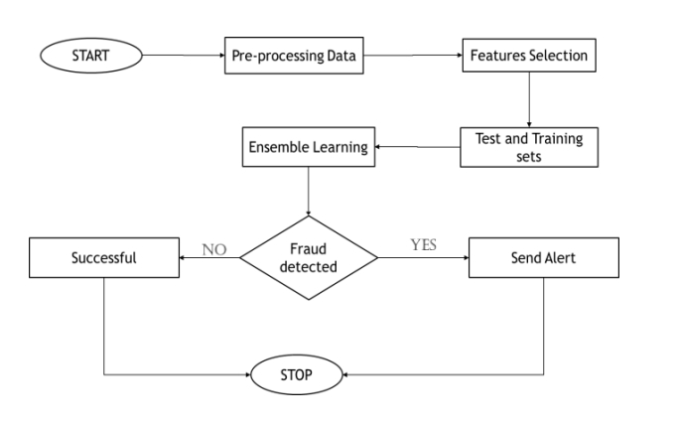

Fig 1.1 Proposed system diagram

SYSTEM REQUIREMENTS AND SPECIFICATION

SOFTWARE REQUIREMENTS
- Front End – Anaconda IDE
- OS: Windows / Linux PC
- Visual Studio
- Backend – SQL
- Language – Python 3.10
- Libraries and Frameworks:
- OpenCV, NumPy,
- CUDA Toolkit 11.2

HARDWARE REQUIREMENTS
- Hard Disk: Greater than 500 GB
- RAM: Greater than 4 GB
- Processor: I3 and Above

REFERENCES

1. "Detecting Financial Fraud using Machine Learning" by IEEE (2020)
2. "UPI Fraud Detection using Machine Learning Algorithms" by International Journal of Advanced Research in Computer Science (2020)
3. "Anomaly Detection in UPI Transactions using Isolation Forest" by arXiv (2020)
4. "Fraud Detection in UPI Payments using Supervised Learning" by Springer (2019)
5. "A Machine Learning Approach to Detecting UPI Fraud" by Journal of Intelligent Information Systems (2019)
6. "UPI Fraud Detection: A Review" by International Journal of Cybersecurity Intelligence and Cyberforensics (2019)
7. "Using Machine Learning to Prevent UPI Fraud" by Payments Journal (2018)
8. "Detecting UPI Fraud using Behavioral Biometrics" by IEEE Transactions on Information Forensics and Security (2018)

